Configured Auto Scaling based on CPU thresholds

- Launched an EC2 Instance

Configure:
- Name: server1
- AMI: Ubuntu
- Instance type: t3.micro
- Key pair: mykey
- Security Group:
  - SSH → Port 22
  - HTTP → Port 80
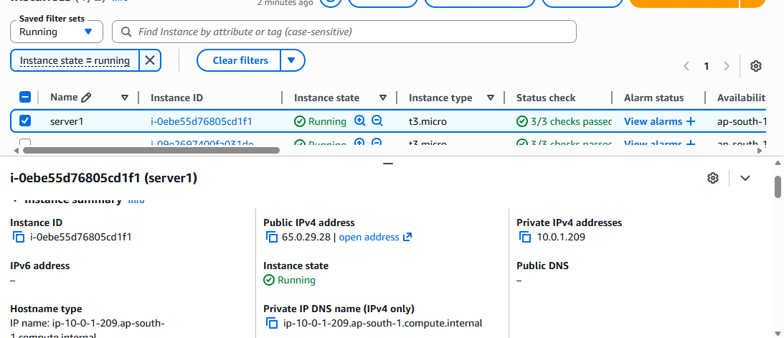
2.Connected and Installed Web server
ssh -i "mykey.pem" ubuntu@65.0.29.28
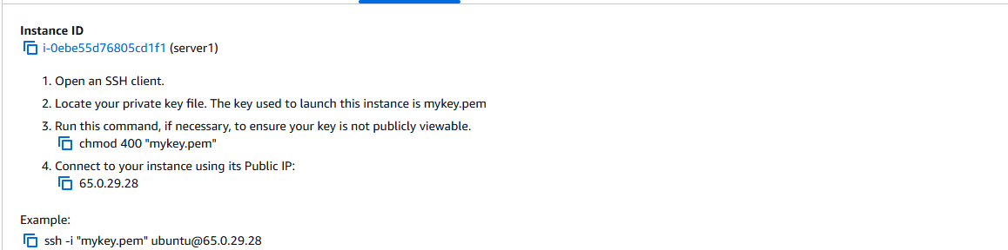
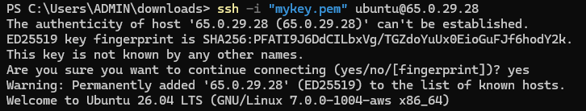
Installed Apache:
sudo apt update
sudo apt install apache2 -y
sudo systemctl start apache2
sudo systemctl enable apache2
Created webpage:
echo "Server from Auto Scaling" | sudo tee /var/www/html/index.html
Checked in browser:
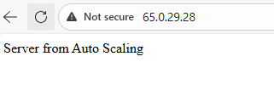
3.Created AMI
Name : AutoScaling-AMI
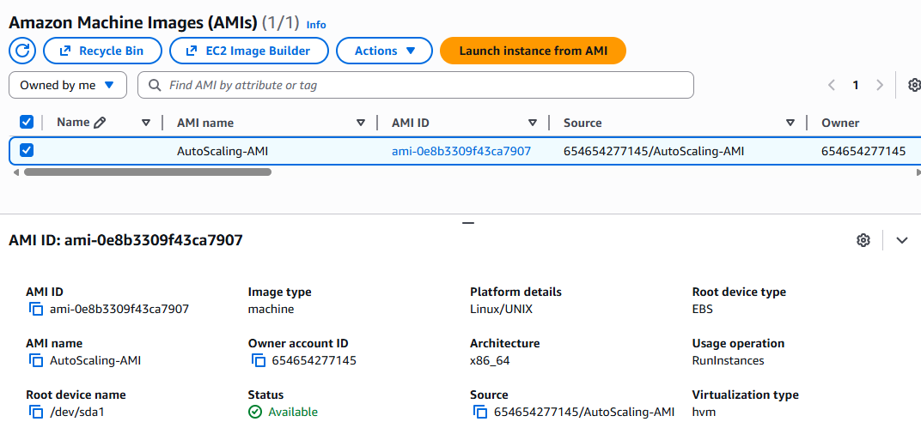
4.Created Target Groups
Configure:
- Target type: Instances
- Protocol: HTTP
- Port: 80
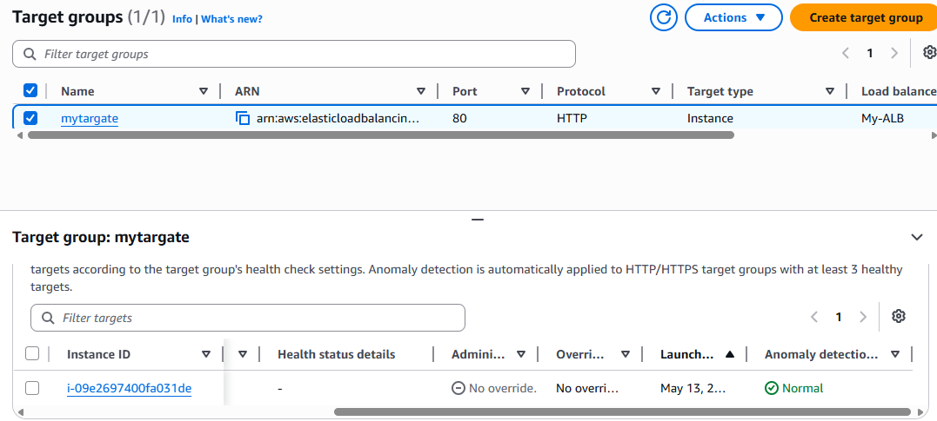
5.Created Application Load balancer
Configure:
- Name: my-alb
- Scheme: Internet-facing
- Select 2 public subnets
- Security Group:
  - Allow HTTP (80)
Listener:
- HTTP : 80
- Forward to target group
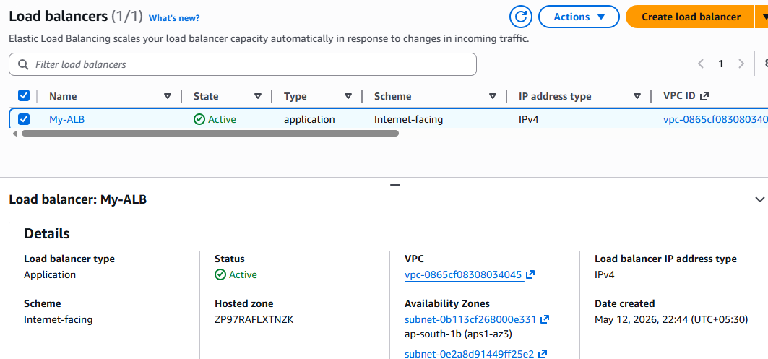
6.Created Launch Template
Template name: my-launch-template
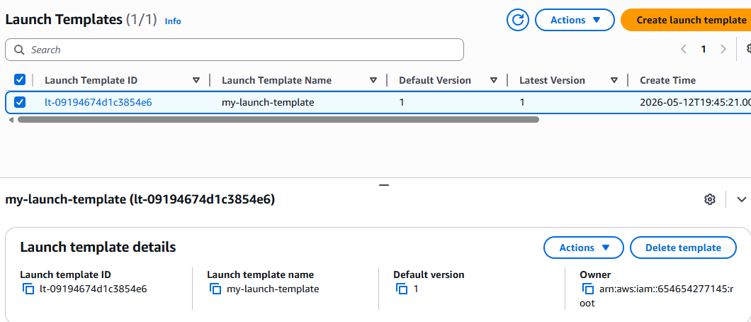
7.Created Autoscaling Group and Configured desired capacity
Name: my-asg
Setting | Value
Desired Capacity | 2
Minimum Capacity | 1
Maximum Capacity | 4
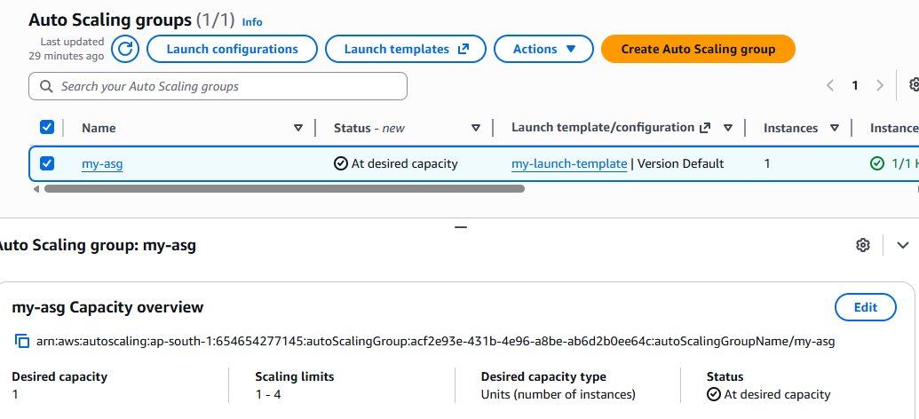
8.Configured Autoscaling policy for CPU
Choose:
Target Tracking Scaling Policy
Metric:
Average CPU Utilization
Target value:
50%

10. Testing Auto scaling

Installed stress tool:

sudo apt install stress -y

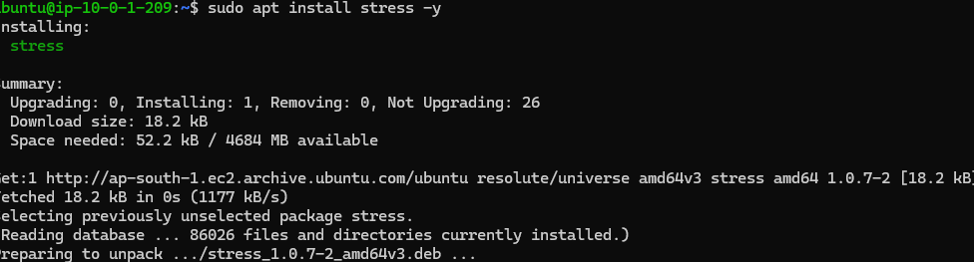
Generated load:
stress --cpu 2 --timeout 300
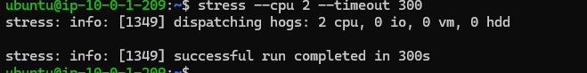
11.Verify Scaling
We can observe new instance is created
EC2 → Auto Scaling Groups → Activity
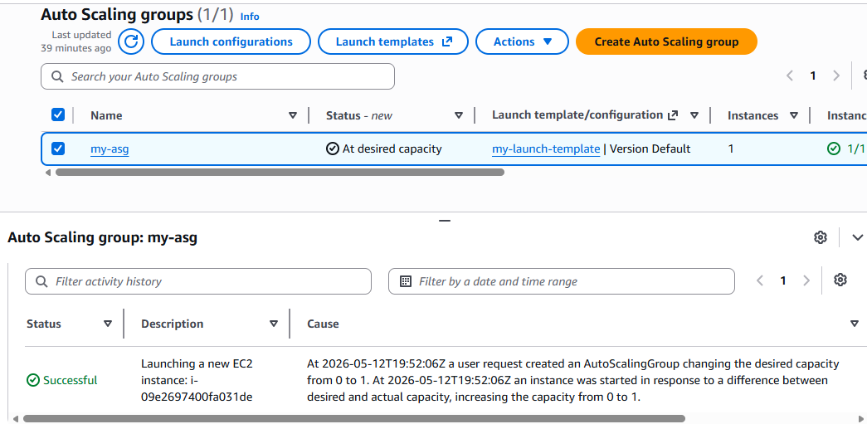
We can see 2 running instances as well
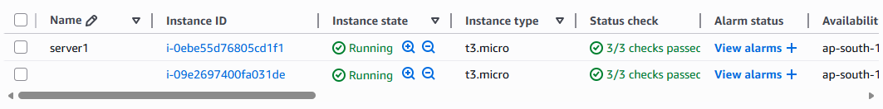
I configured Auto Scaling using a Launch Template, Application Load Balancer, and Target Tracking Policy based on CPU utilization. When CPU crossed 50%, Auto Scaling automatically launched new EC2 instances and attached them to the target group. When CPU usage decreased, extra instances were terminated automatically, ensuring high availability and cost optimization.

